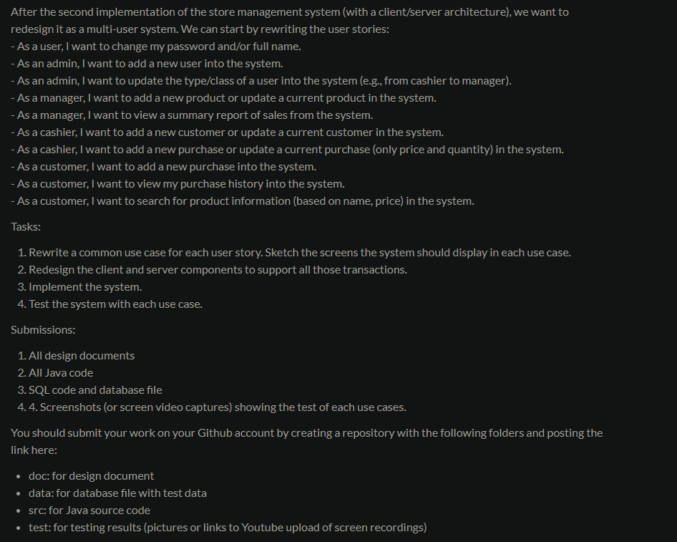

Tasks:

1. Rewrite two common use cases for each user story. Sketch the screens the system should display in each use case.

EACH USER STORY

- As a user, I want to change my password and/or full name.

2 use cases could be changing your own password, or changing your name

- As an admin, I want to add a new user into the system.

2 use cases could be management adding a new customer, or updating customer information

- As an admin, I want to update the type/class of a user into the system (e.g., from cashier to manager).

- As a manager, I want to add a new product or update a current product in the system.

2 use cases could be adding a new product or updating a current product in the system.

- As a manager, I want to view a summary report of sales from the system.

2 use cases could be wanting to report on the daily sales to the owner, or to review the performance of the store over a longer time.

- As a cashier, I want to add a new customer or update a current customer in the system.

2 use cases could be a cashier wanting to add a new customer or update a current customers information in the system.

- As a cashier, I want to add a new purchase or update a current purchase (only price and quantity) in the system.

2 use cases could be wanting to add a new purchase or update a past purchase in the system

- As a customer, I want to add a new purchase into the system.

2 use cases could be a customer adding a new purchase or updating a current purchase in the system

- As a customer, I want to search for product information (based on name, price) in the system.

2 use cases could be a customer adding a new purchase or updating a current purchase in the system

- As a customer, I want to view my purchase history into the system.

2 use cases could be a customer wanting to know how much they have spent, and another use case being to check the date that they purchased something.

1. Redesign the client and server components to support all those transactions.

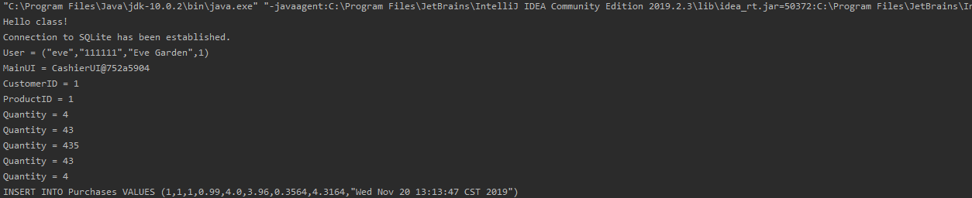

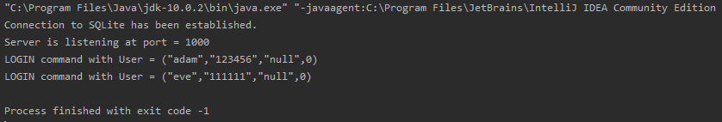

1. Implement the system.

DONE!

1. Test the system with each use case.

DONE! Pictures are in the pictures folder labeled test